AI Literacy Level 3
Louise Pardy Greenshaw Learning Trust

Sprint 1 Part 4 Graded Exercise 1
AI hunting on LinkedIn!

Requirement – Save screenshots of at least 10 social media posts or replies of your choice. Next to each one, write whether you believe it to be primarily AI-generated or not and what your reasoning is.

My guess is that 40% of the post on LinkedIn will be AI-written

- I think that this is human generated – I couldn’t spot any evidence of AI use,
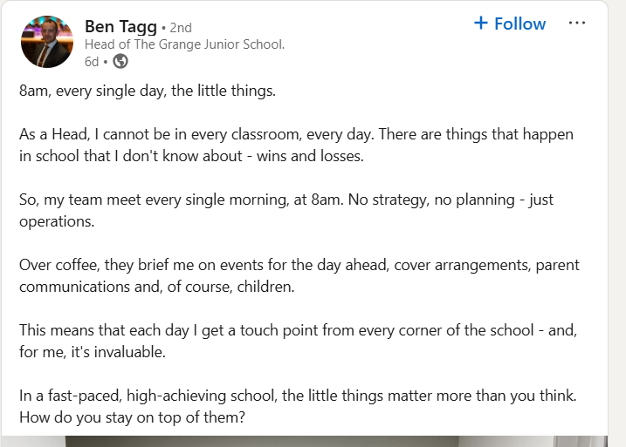

- I think that this is AI – written. Because of the em dash use and the use of an odd number of points.

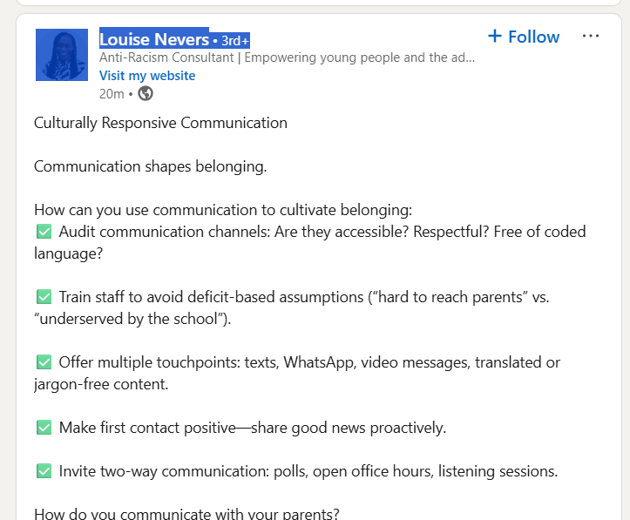

- I think that this AI generated. Because of the use of odd number of points, emojis and parallel sentence structure.

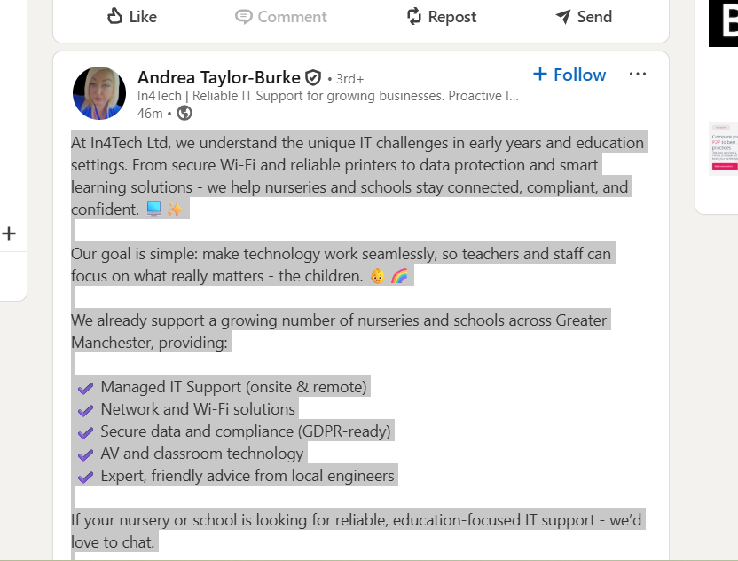

- I think that this AI generated. Because of the use of odd number of points, emojis and the em dash
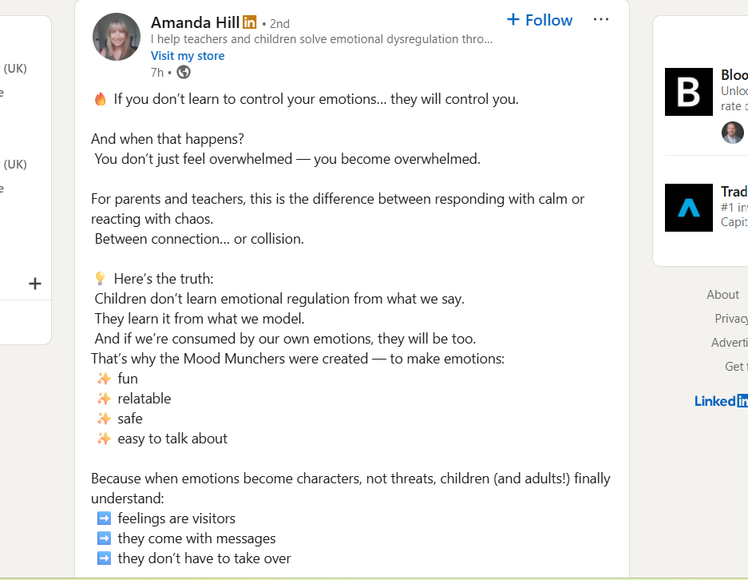

- I think that this is human generated – the post is relatable and personable

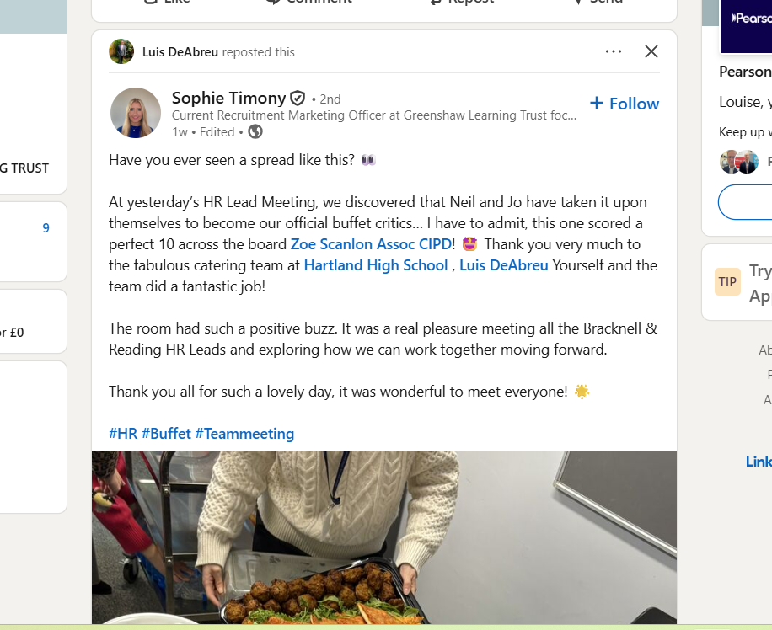

- In the end I thought that this post was AI generated – mainly because of the em dash.
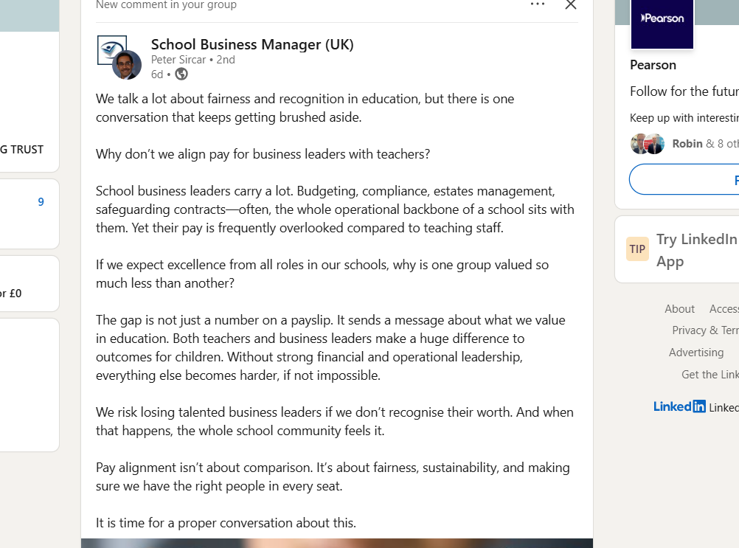

- I think that this is human generated – because it’s very personable.
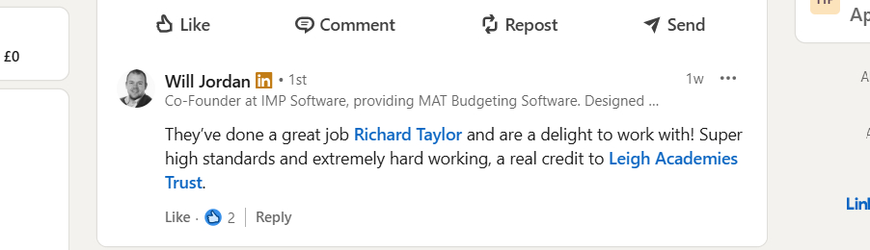

- I think that this is human generated – the post seems to me to be very genuine
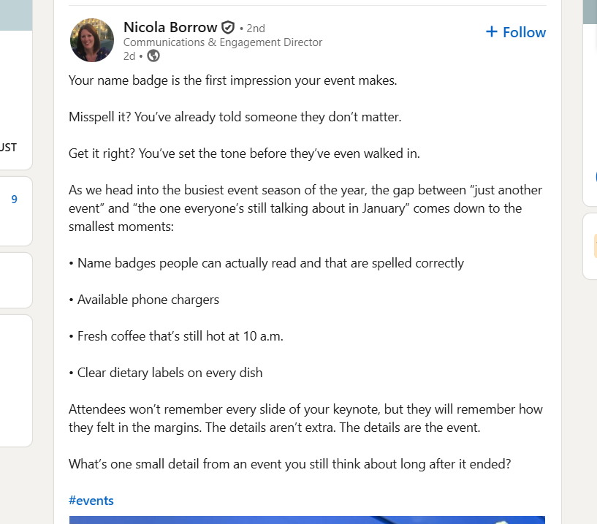

- I think that this post is 100% AI. Because of the use of emojis and the em dash


- Despite the emojis and odd number of points, I think that this is human generated. It feels genuine and personable.
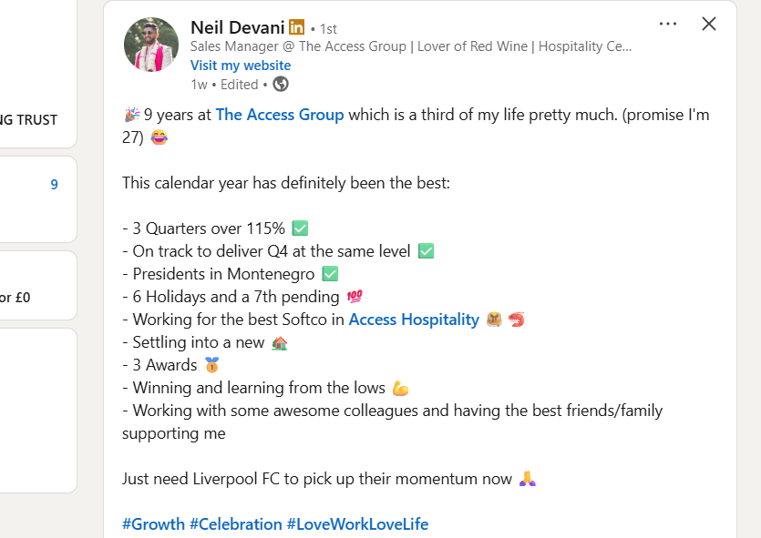

In the end the result was 50:50

